Exp no:1

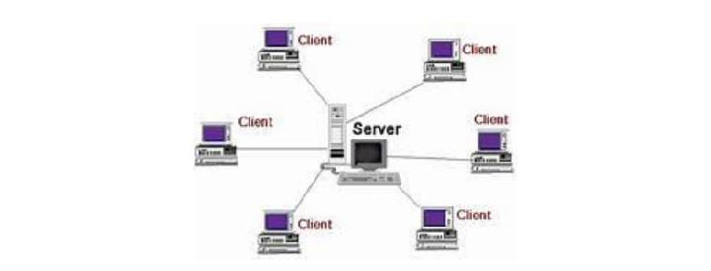

Exp no:2

STAR TOP0LOGY

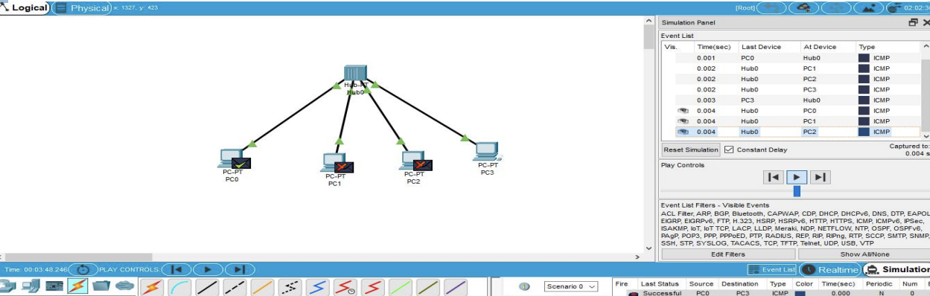

MESH TOPOLOGY

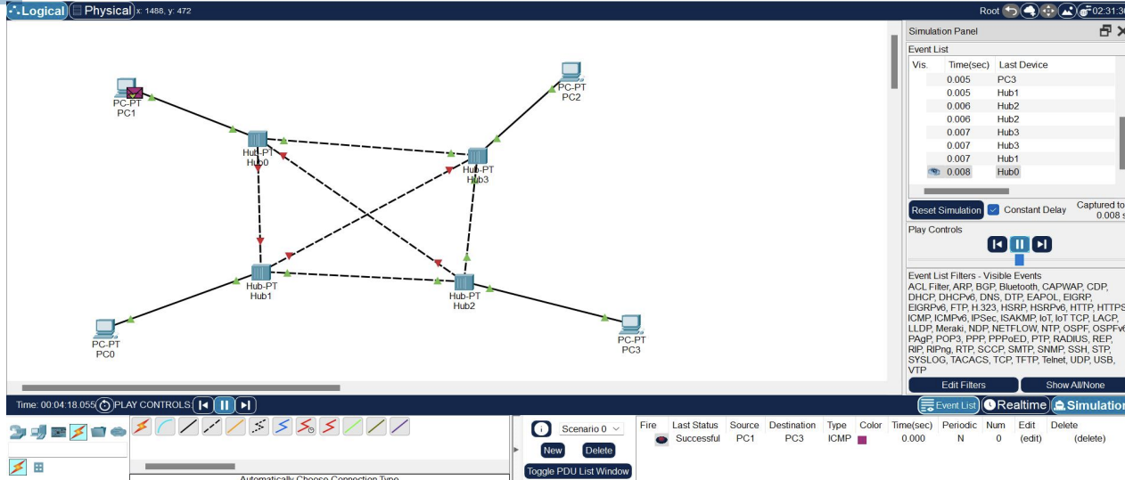

TREE TOPOLOGY

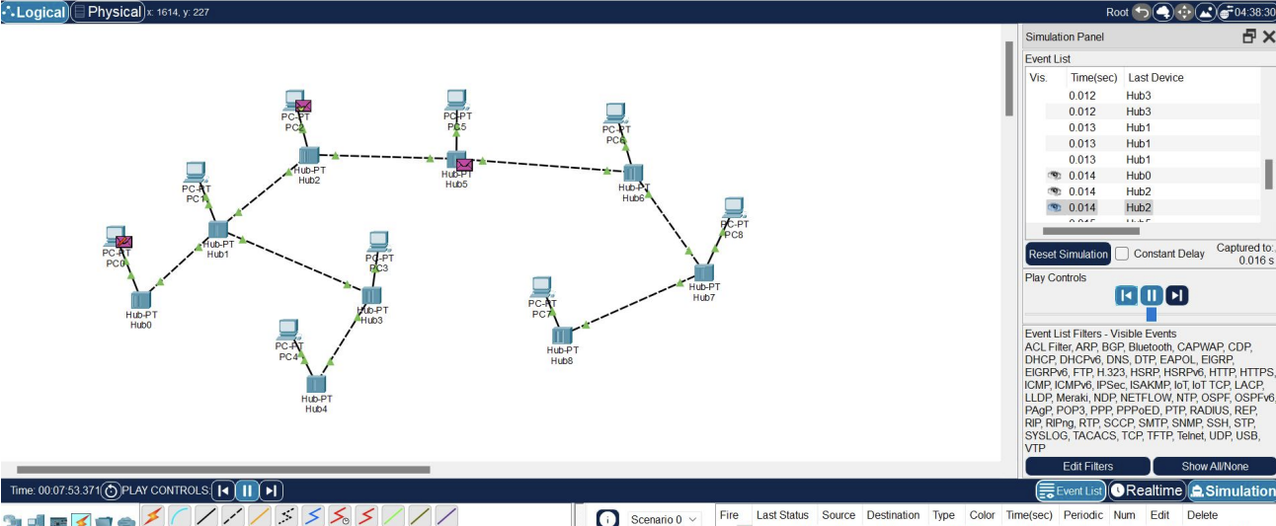

BUS TOPOLOGY

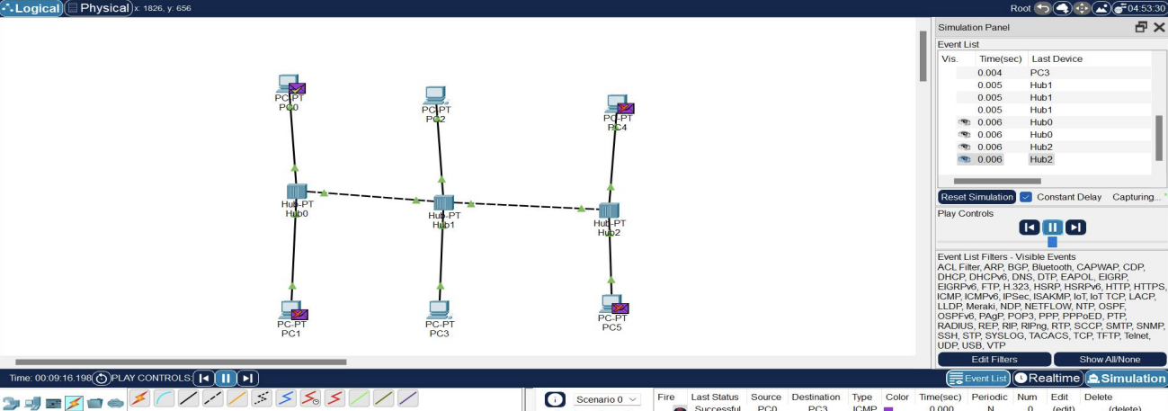

RING TOPLOGY

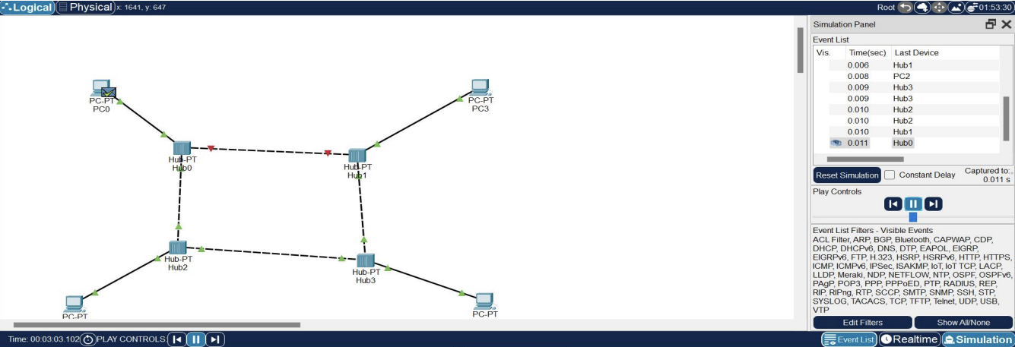

HYBRID TOPOLOGY

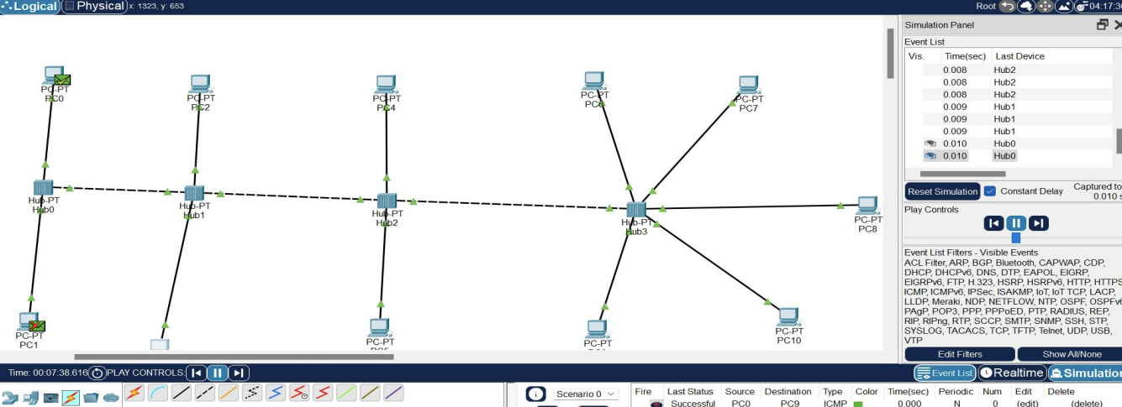

EXPNO : 3

CSMA/CA & CSMA/CA

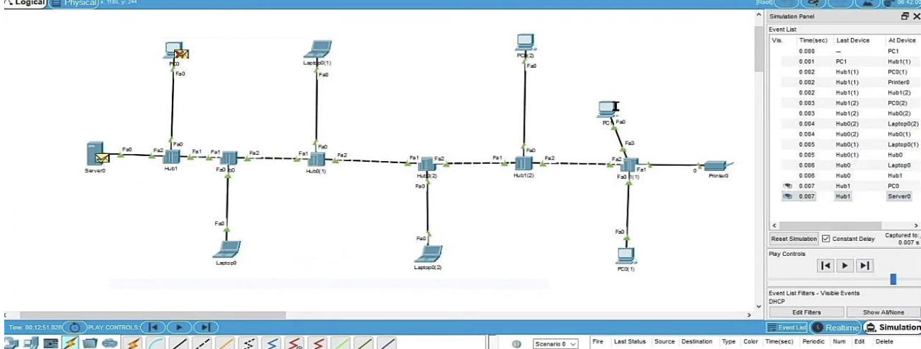

EXP NO 4:

ARP

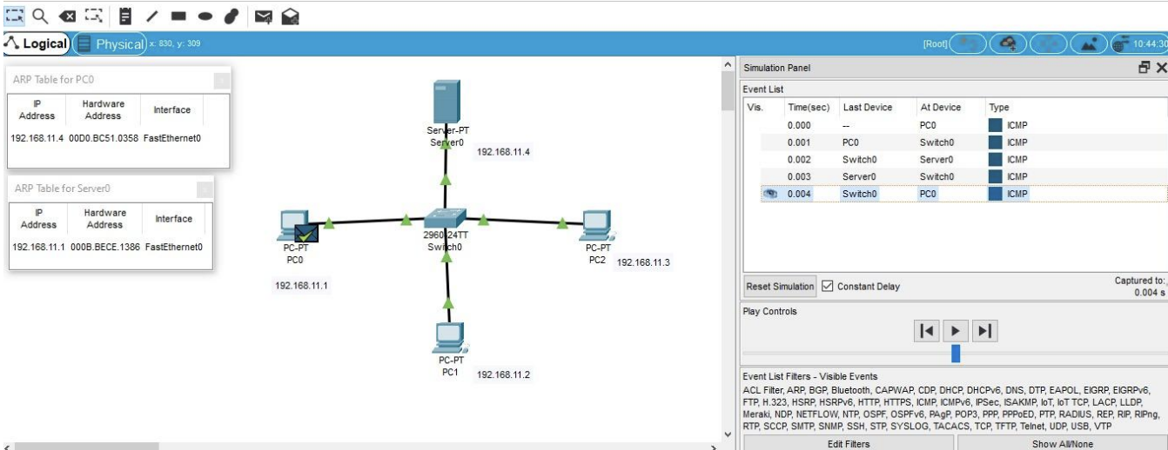

EXP NO : 5

LLDP

